Napa Hall AV Guide

Napa Hall Podium 2

Napa Hall Podium Connections 3

Connecting your Laptop to the projector via HDMI 3

Connecting your Laptop to the projector via VGA and Audio Cable 5

Connecting your Laptop to ShareLink using the ShareLink Pro App 8

Connecting your Laptop to ShareLink through the web browser 12

Handheld Microphone 20

Lapel Microphone 22

## Napa Hall Podium

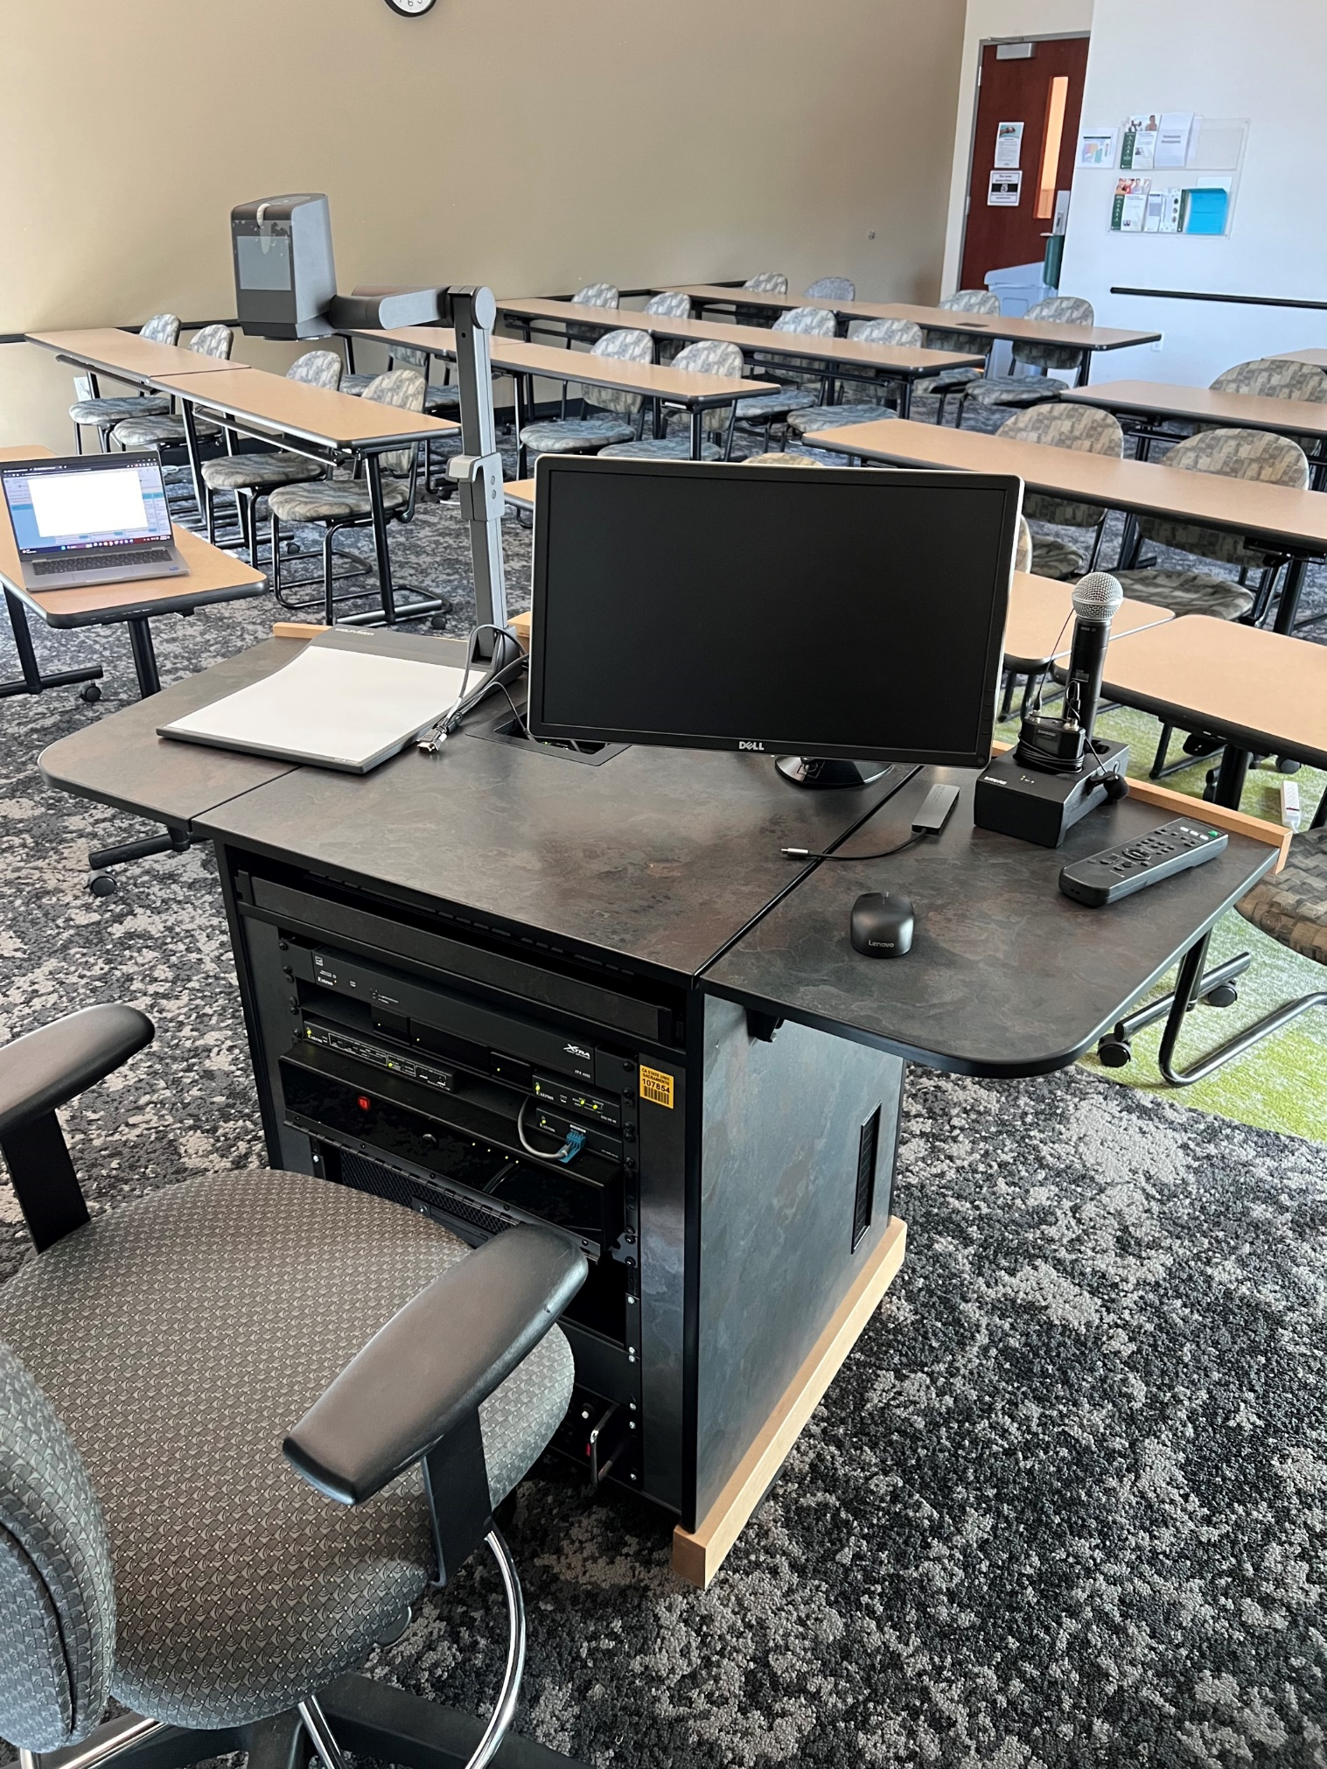

## Napa Hall Podium Connections

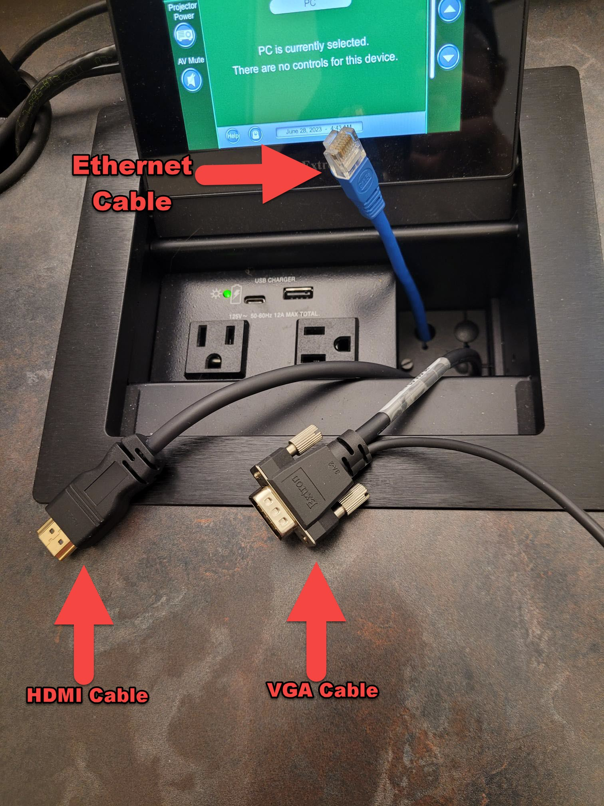

## Connecting your Laptop to the projector via HDMI

* Connect the podiums HDMI cable into the HDMI port on your computer.

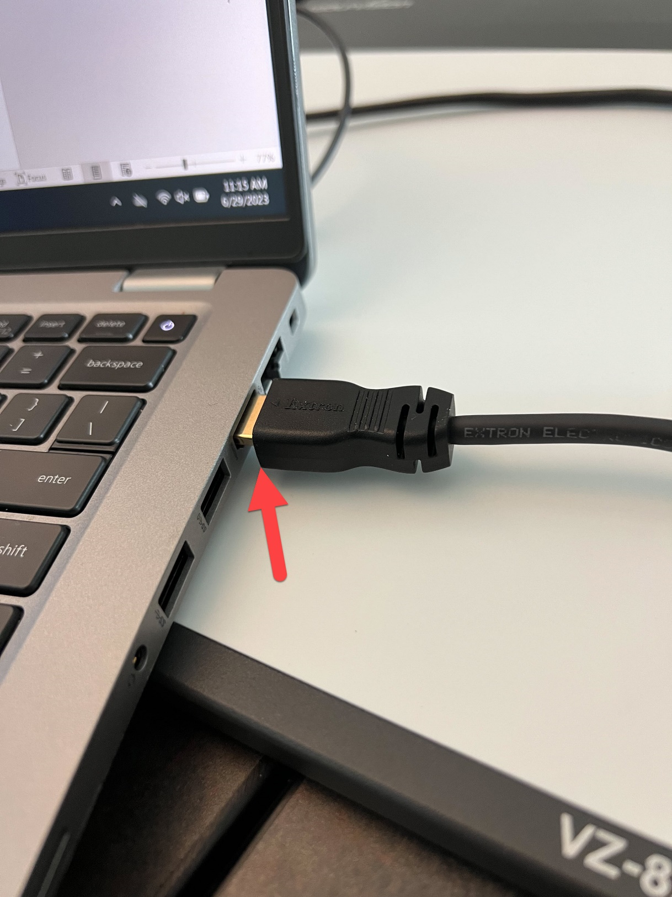

* Switch the source on the touchscreen to HDMI by tapping Laptop HDMI.

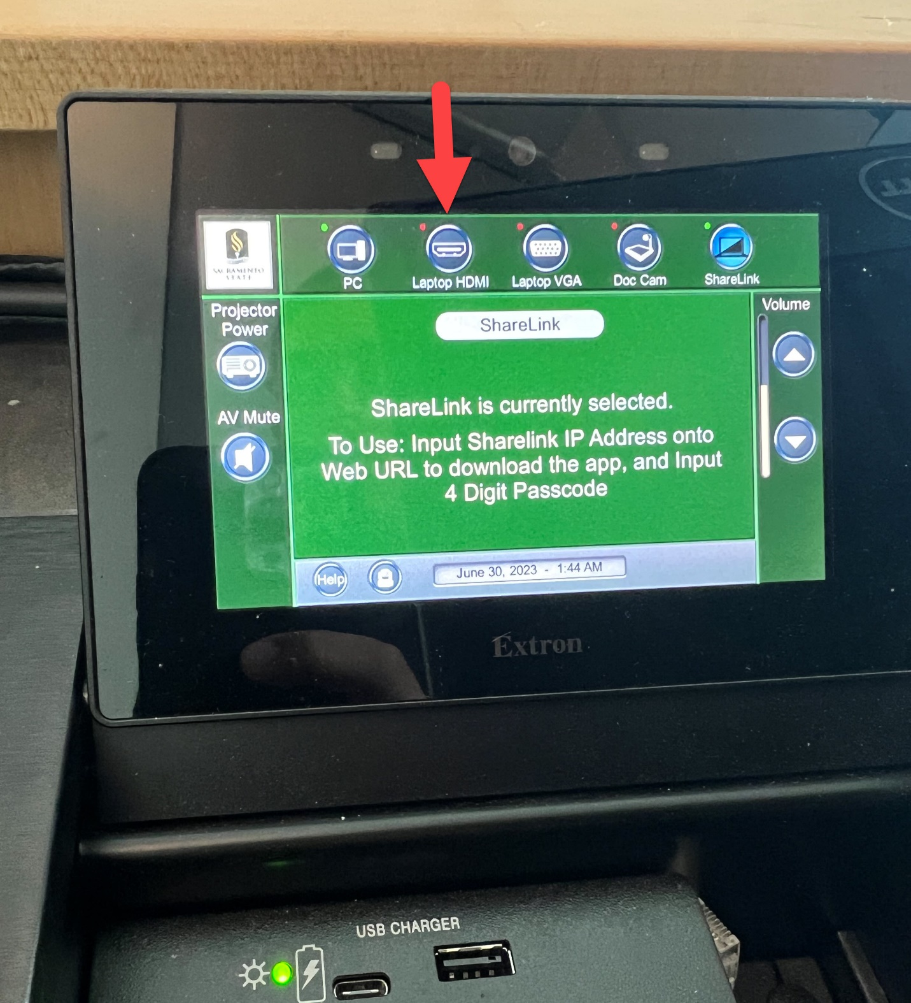

## Connecting your Laptop to the projector via VGA and Audio Cable

* Connect the podiums VGA cable to the VGA port on your computer.
* Connect the podiums Audio cable to the audio port on your computer.

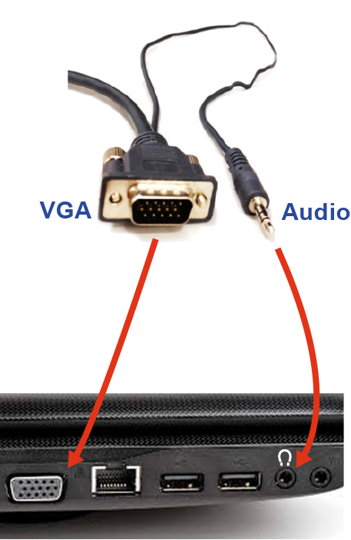

* Switch the source on the touchscreen to VGA by tapping Laptop VGA.

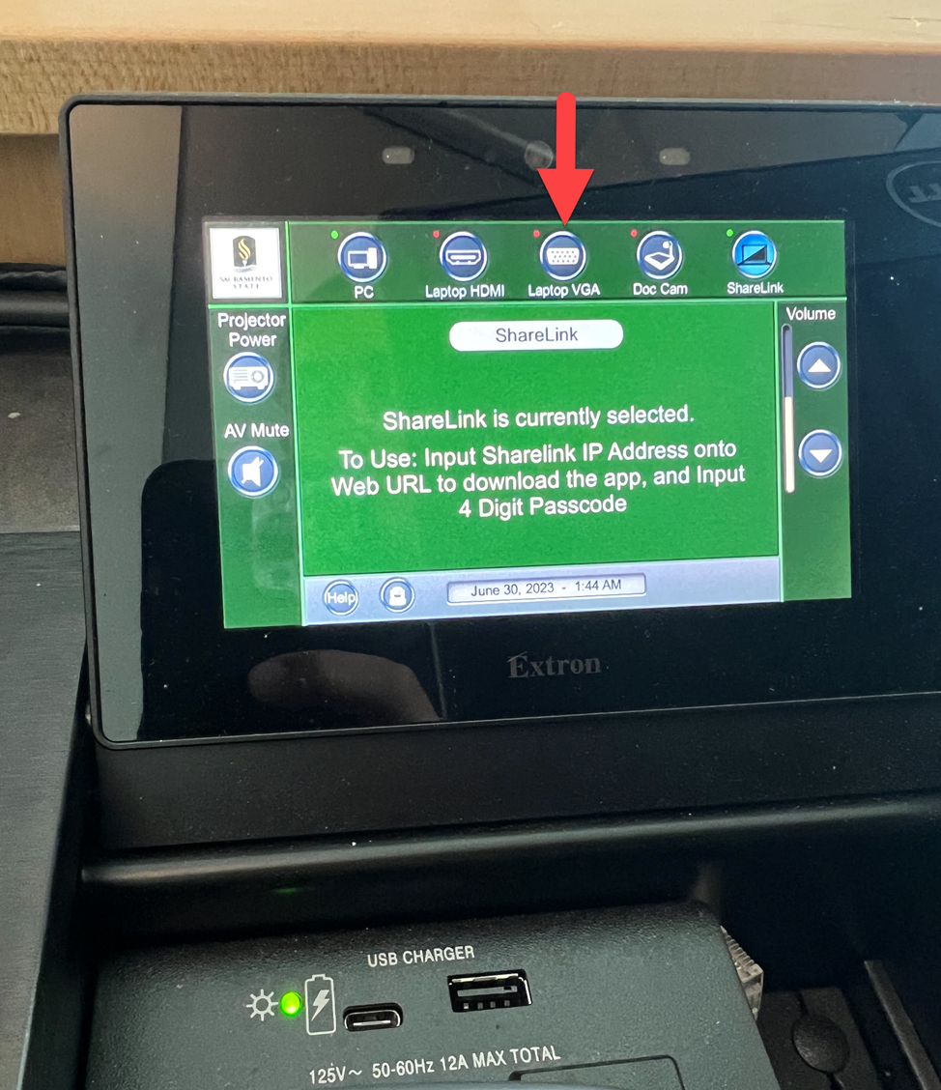

## Connecting your Laptop to ShareLink using the ShareLink Pro App

* Switch the source on the touchscreen to ShareLink by tapping on ShareLink.

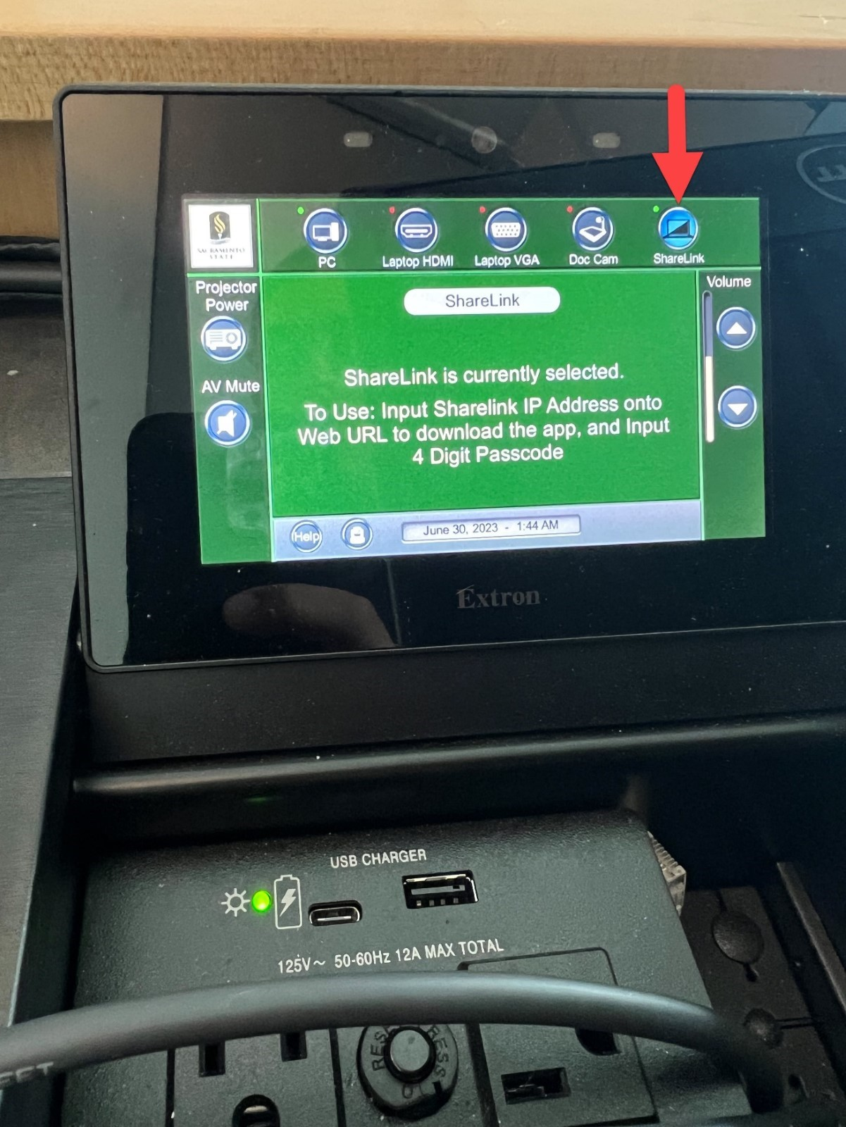

* You will see your devices IP address at the bottom of the screen

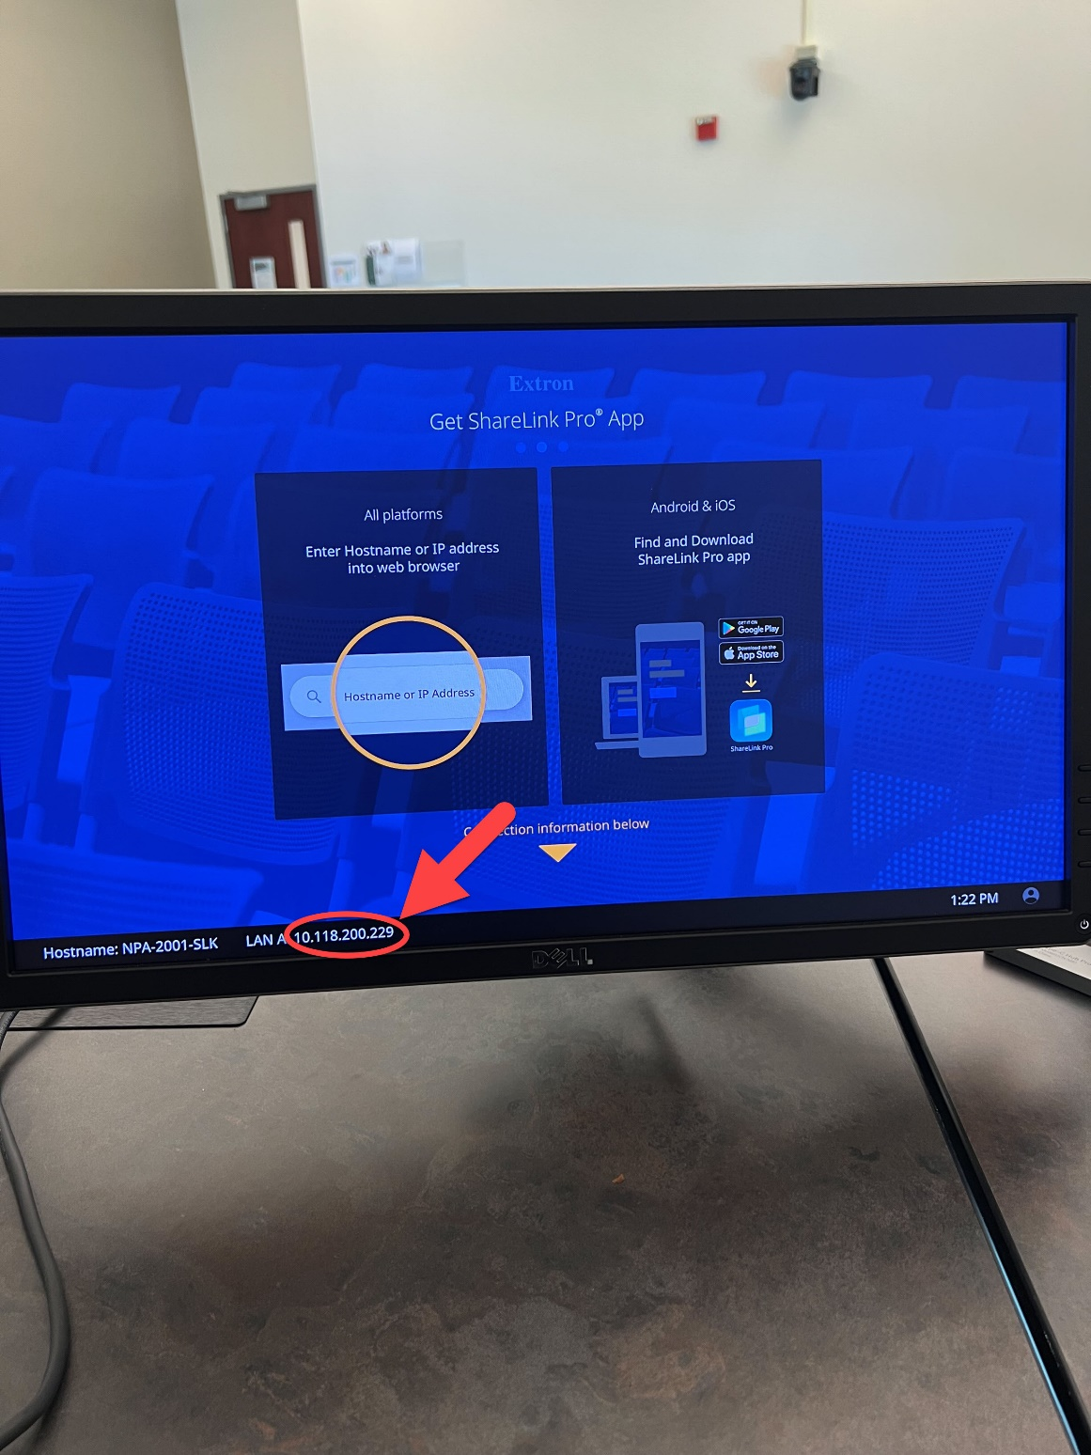

* Open the Sharelink Pro App and click on the plus sign.

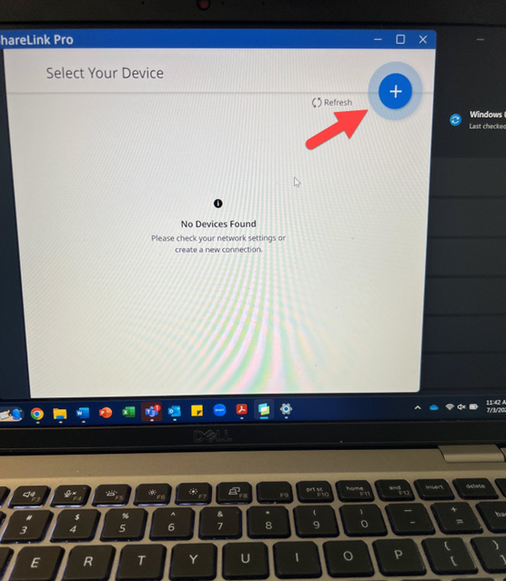

Enter the IP Address and Click Next

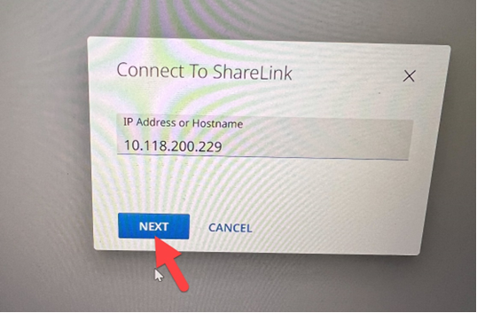

* Click the plus sign to start sharing your screen.

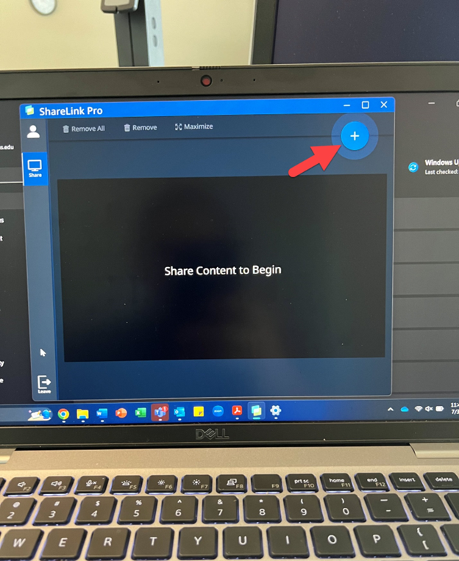

* Select the option you want to share.

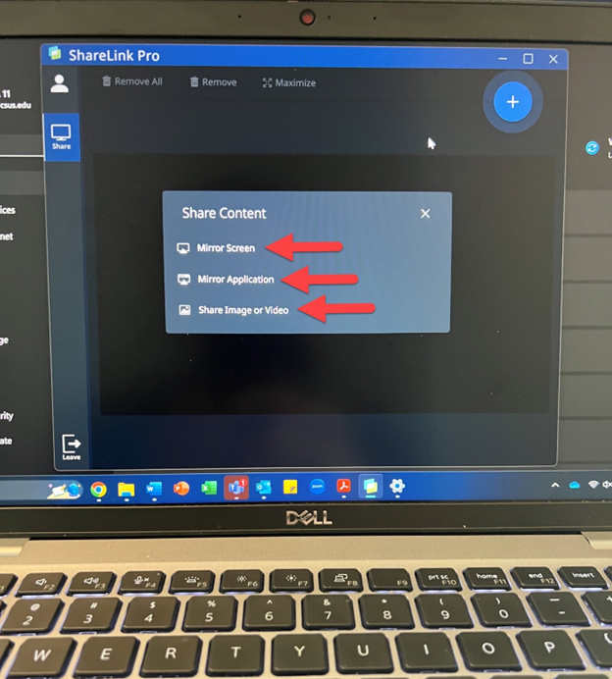

## Connecting your Laptop to ShareLink through the web browser

* + Switch the source on the touchscreen to ShareLink by tapping on ShareLink.

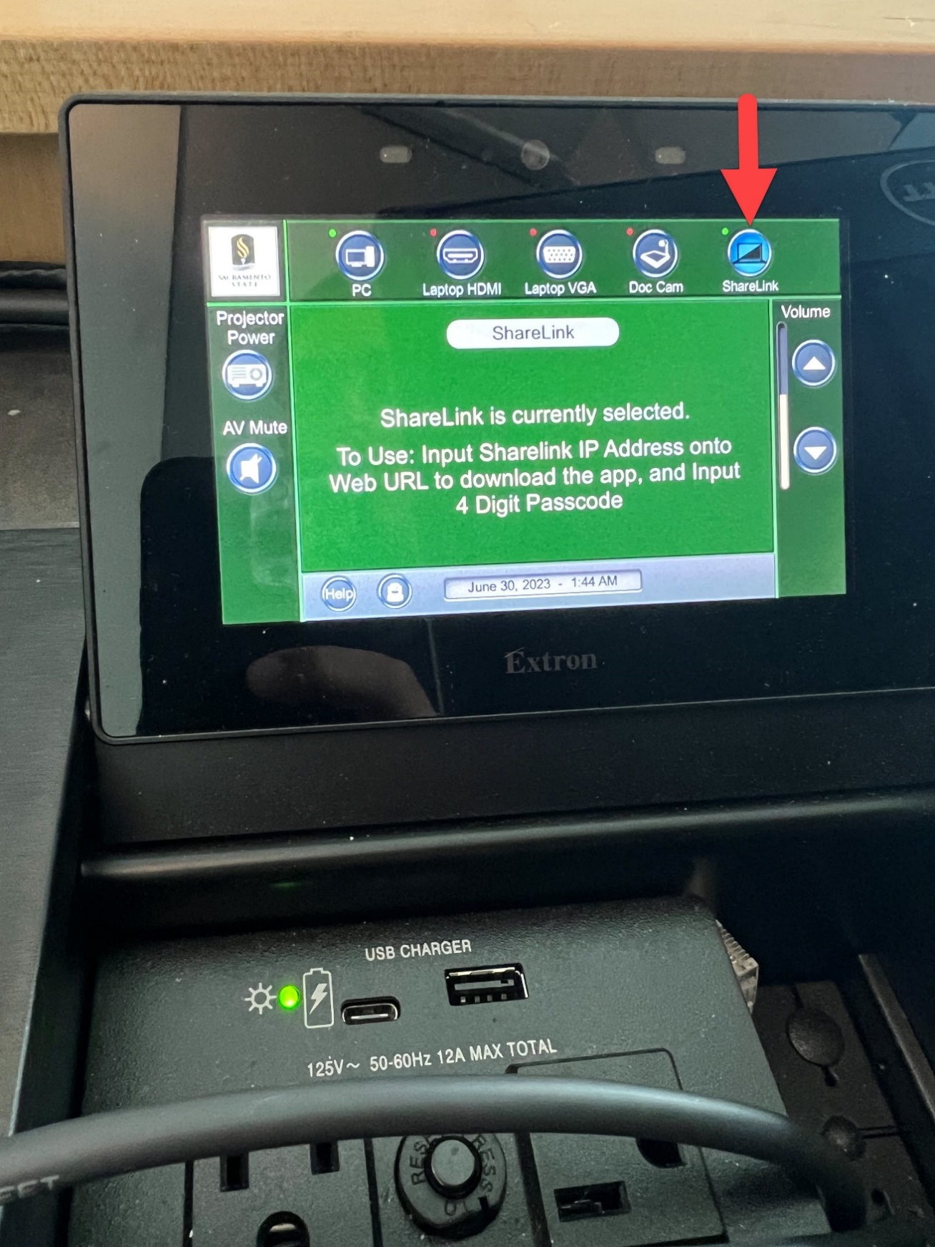

* + At the bottom of the screen, you will see your devices IP address.

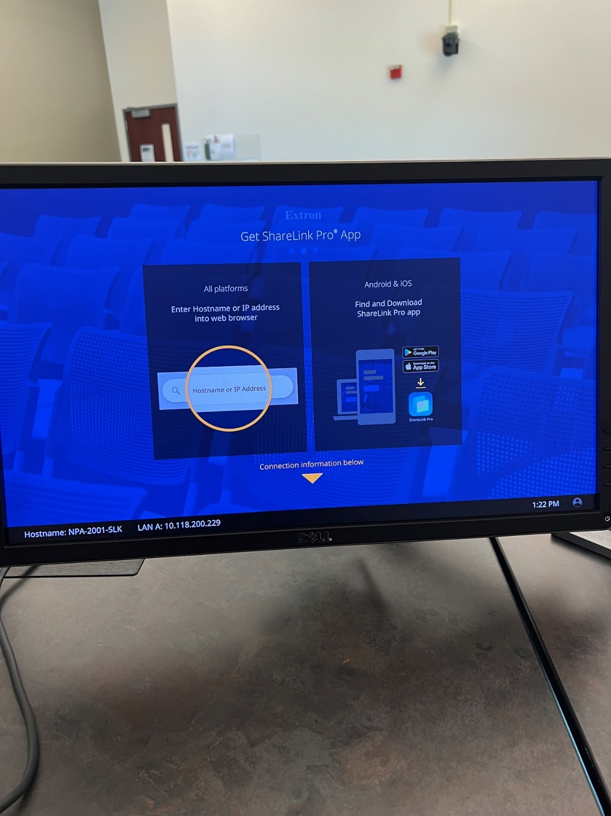

* Open your internet browser of choice and type that number into the address bar of your internet browser.

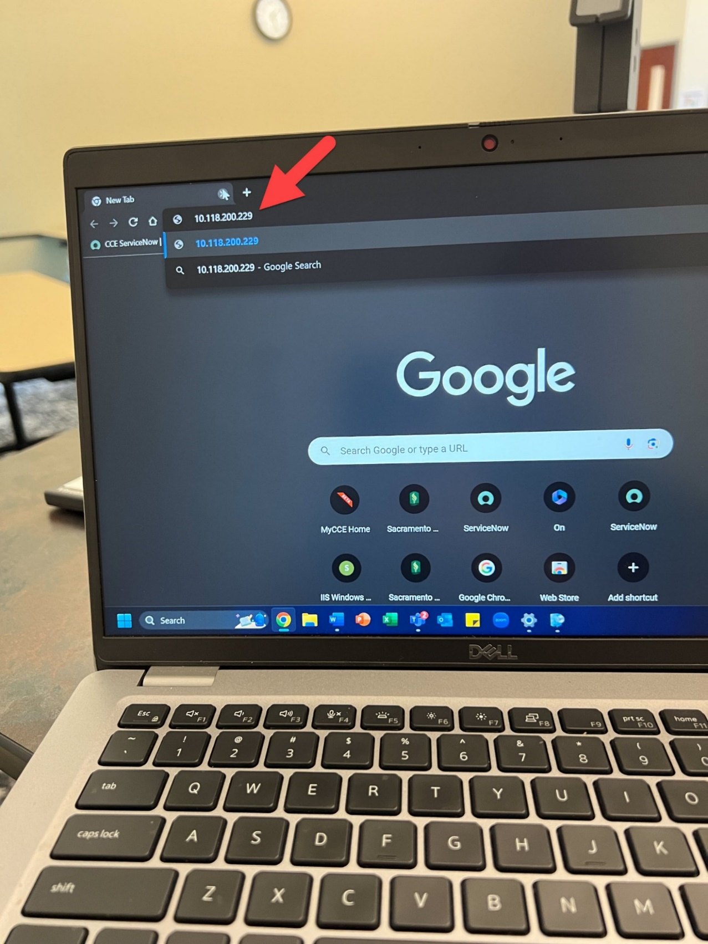

* + If you get an error saying your connection is not private, click advanced.

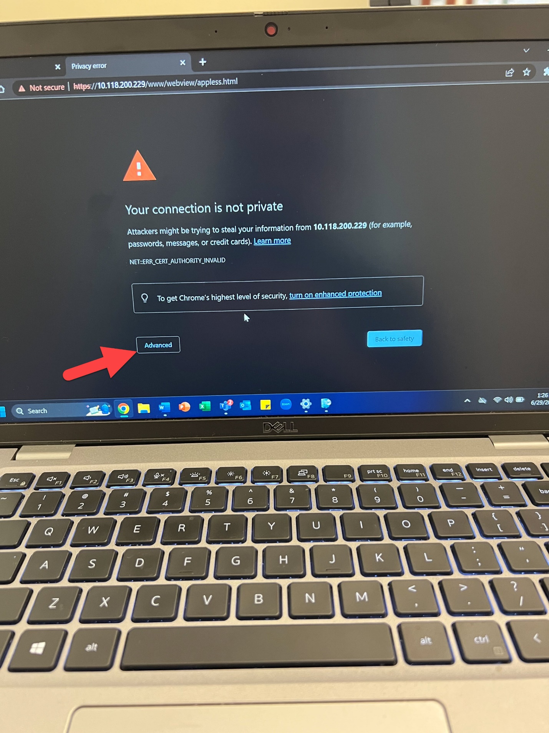

* + Then click Proceed

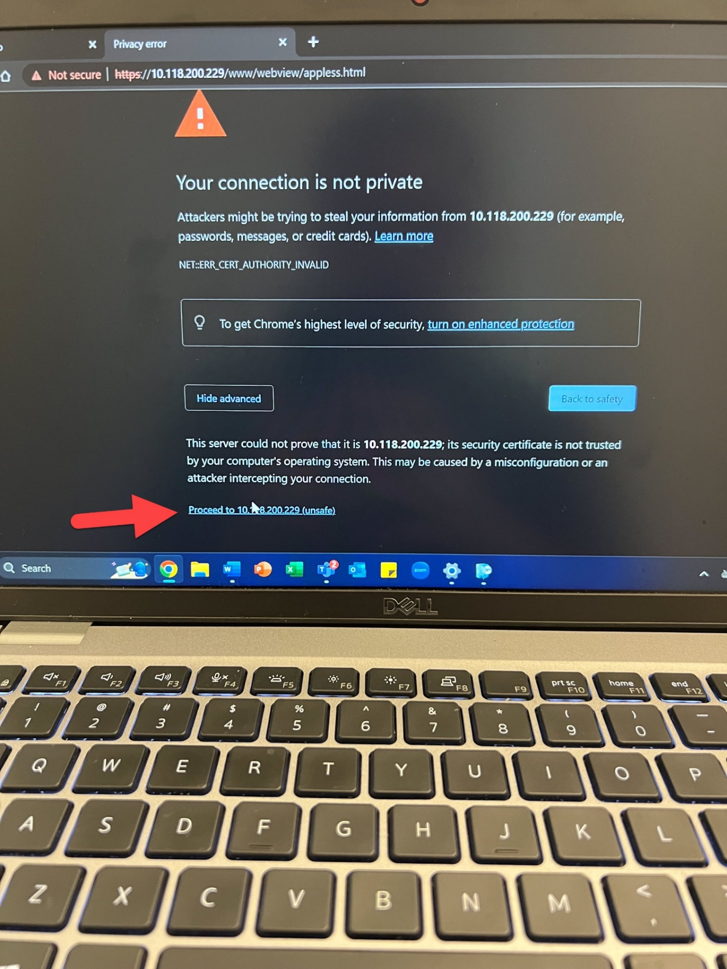

* + You will see this screen and you will click share.

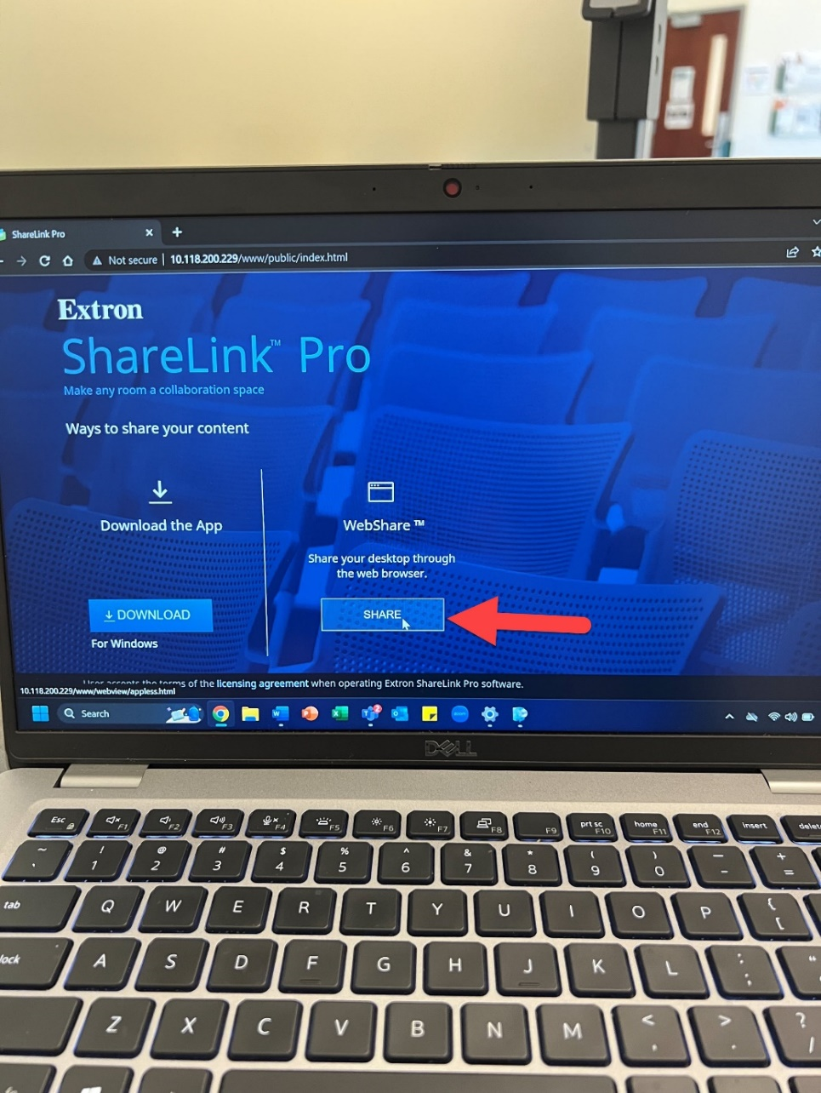

* + Enter your name and press connect.

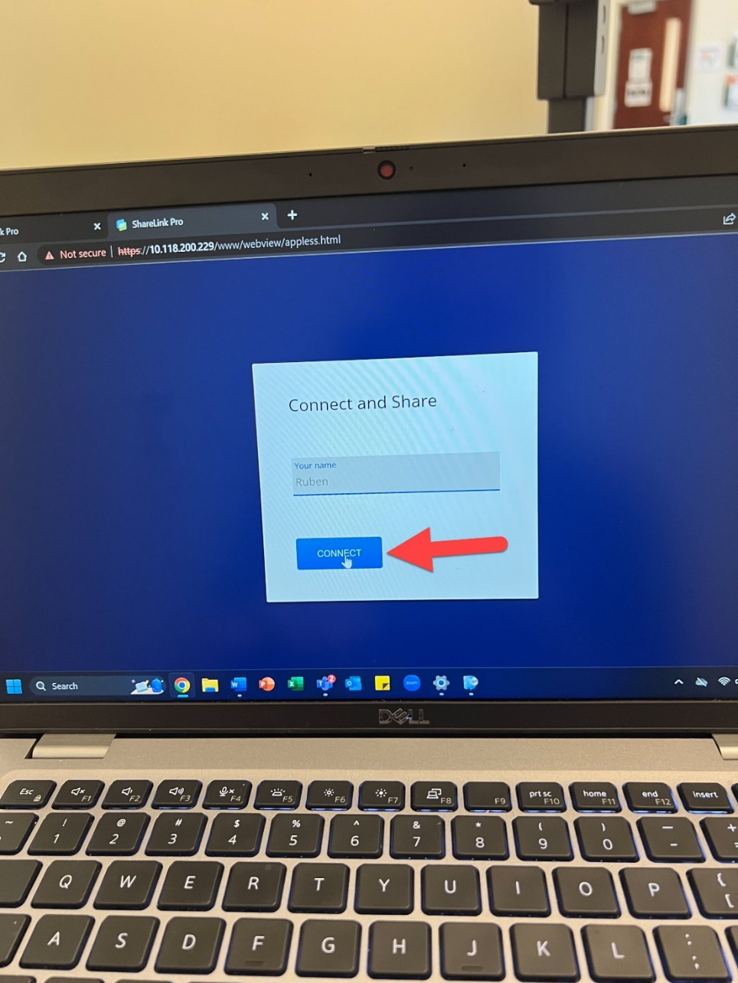

* + Select the option you want to share

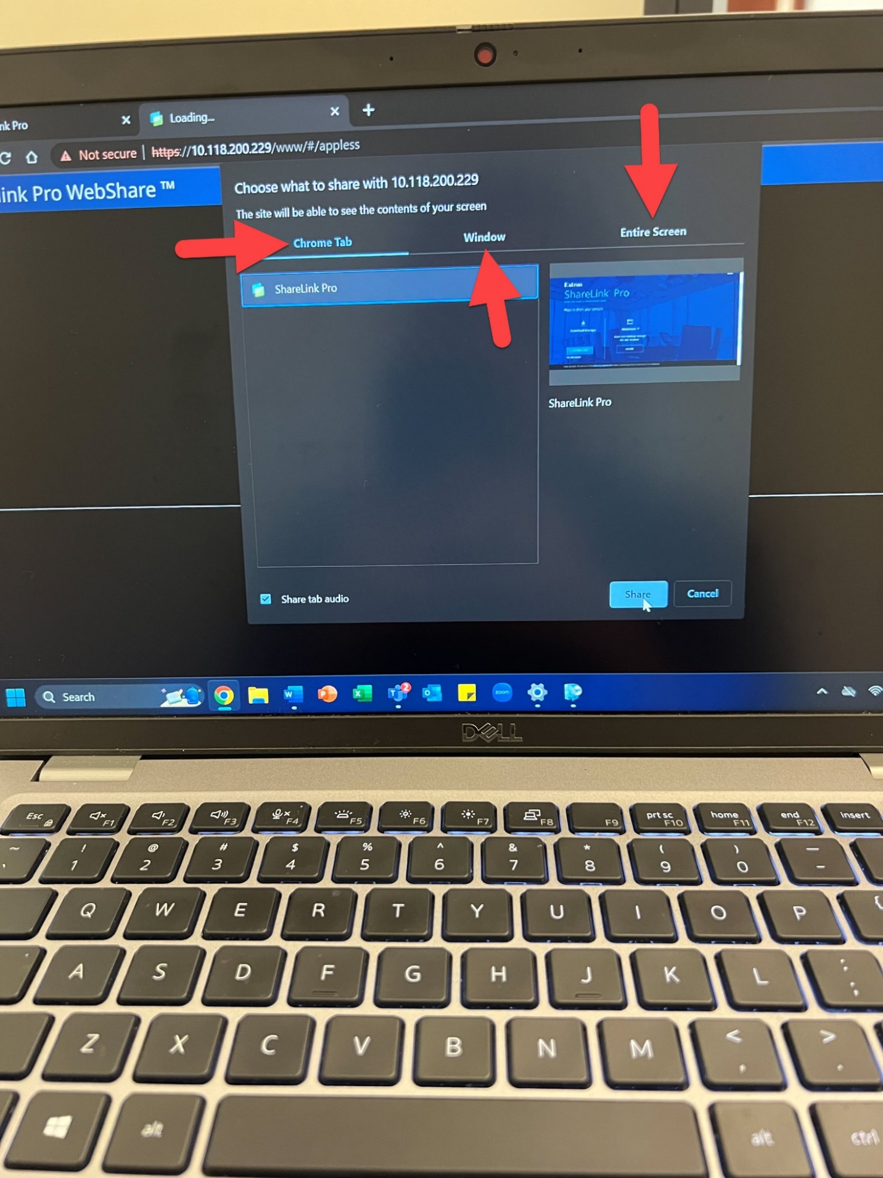

* + After you select the option you want to share, click the share button.

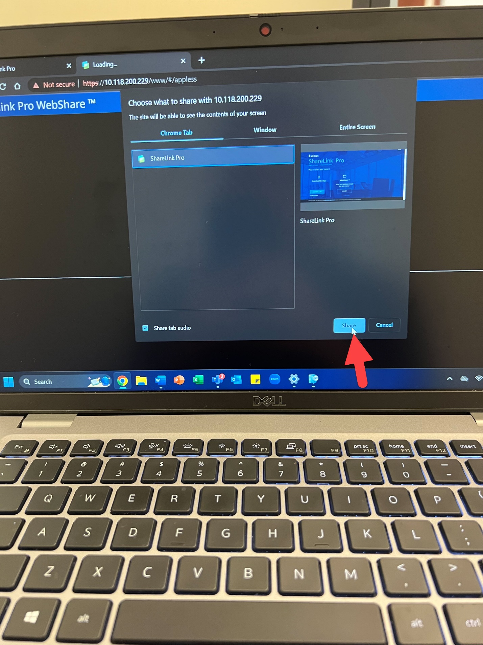

## Handheld Microphone

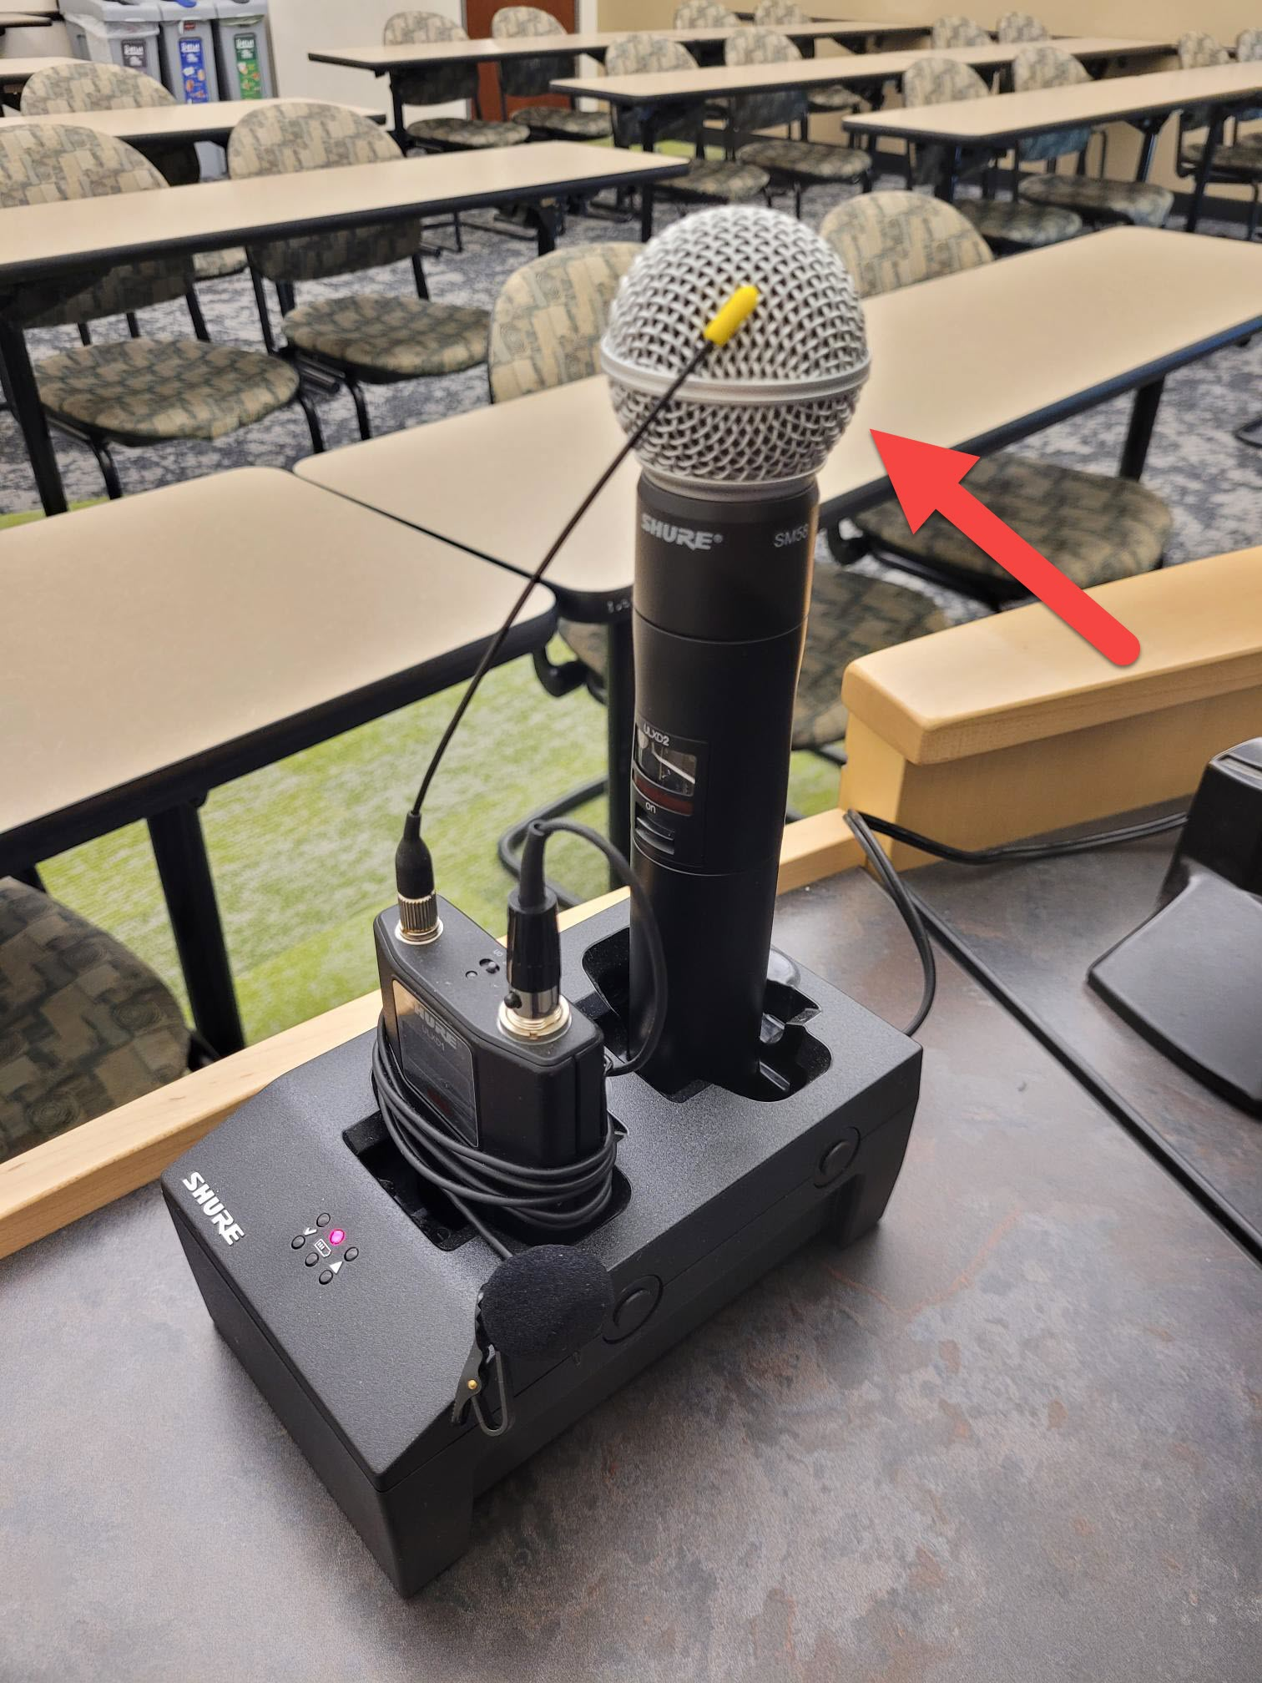

* Pull the handheld microphone out of its dock and move the switch up to the on position.

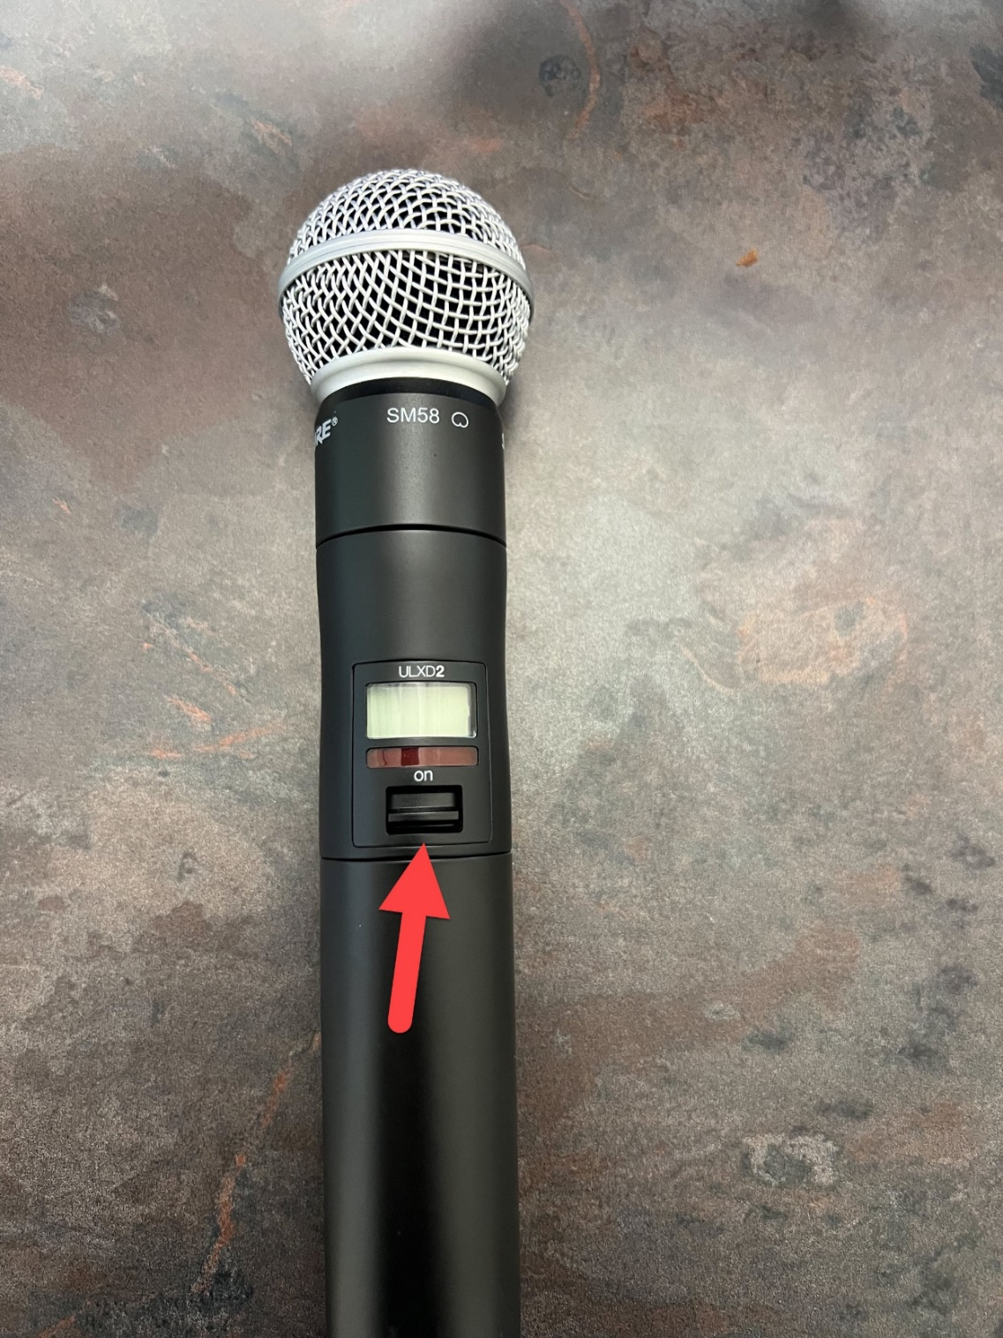

## Lapel Microphone

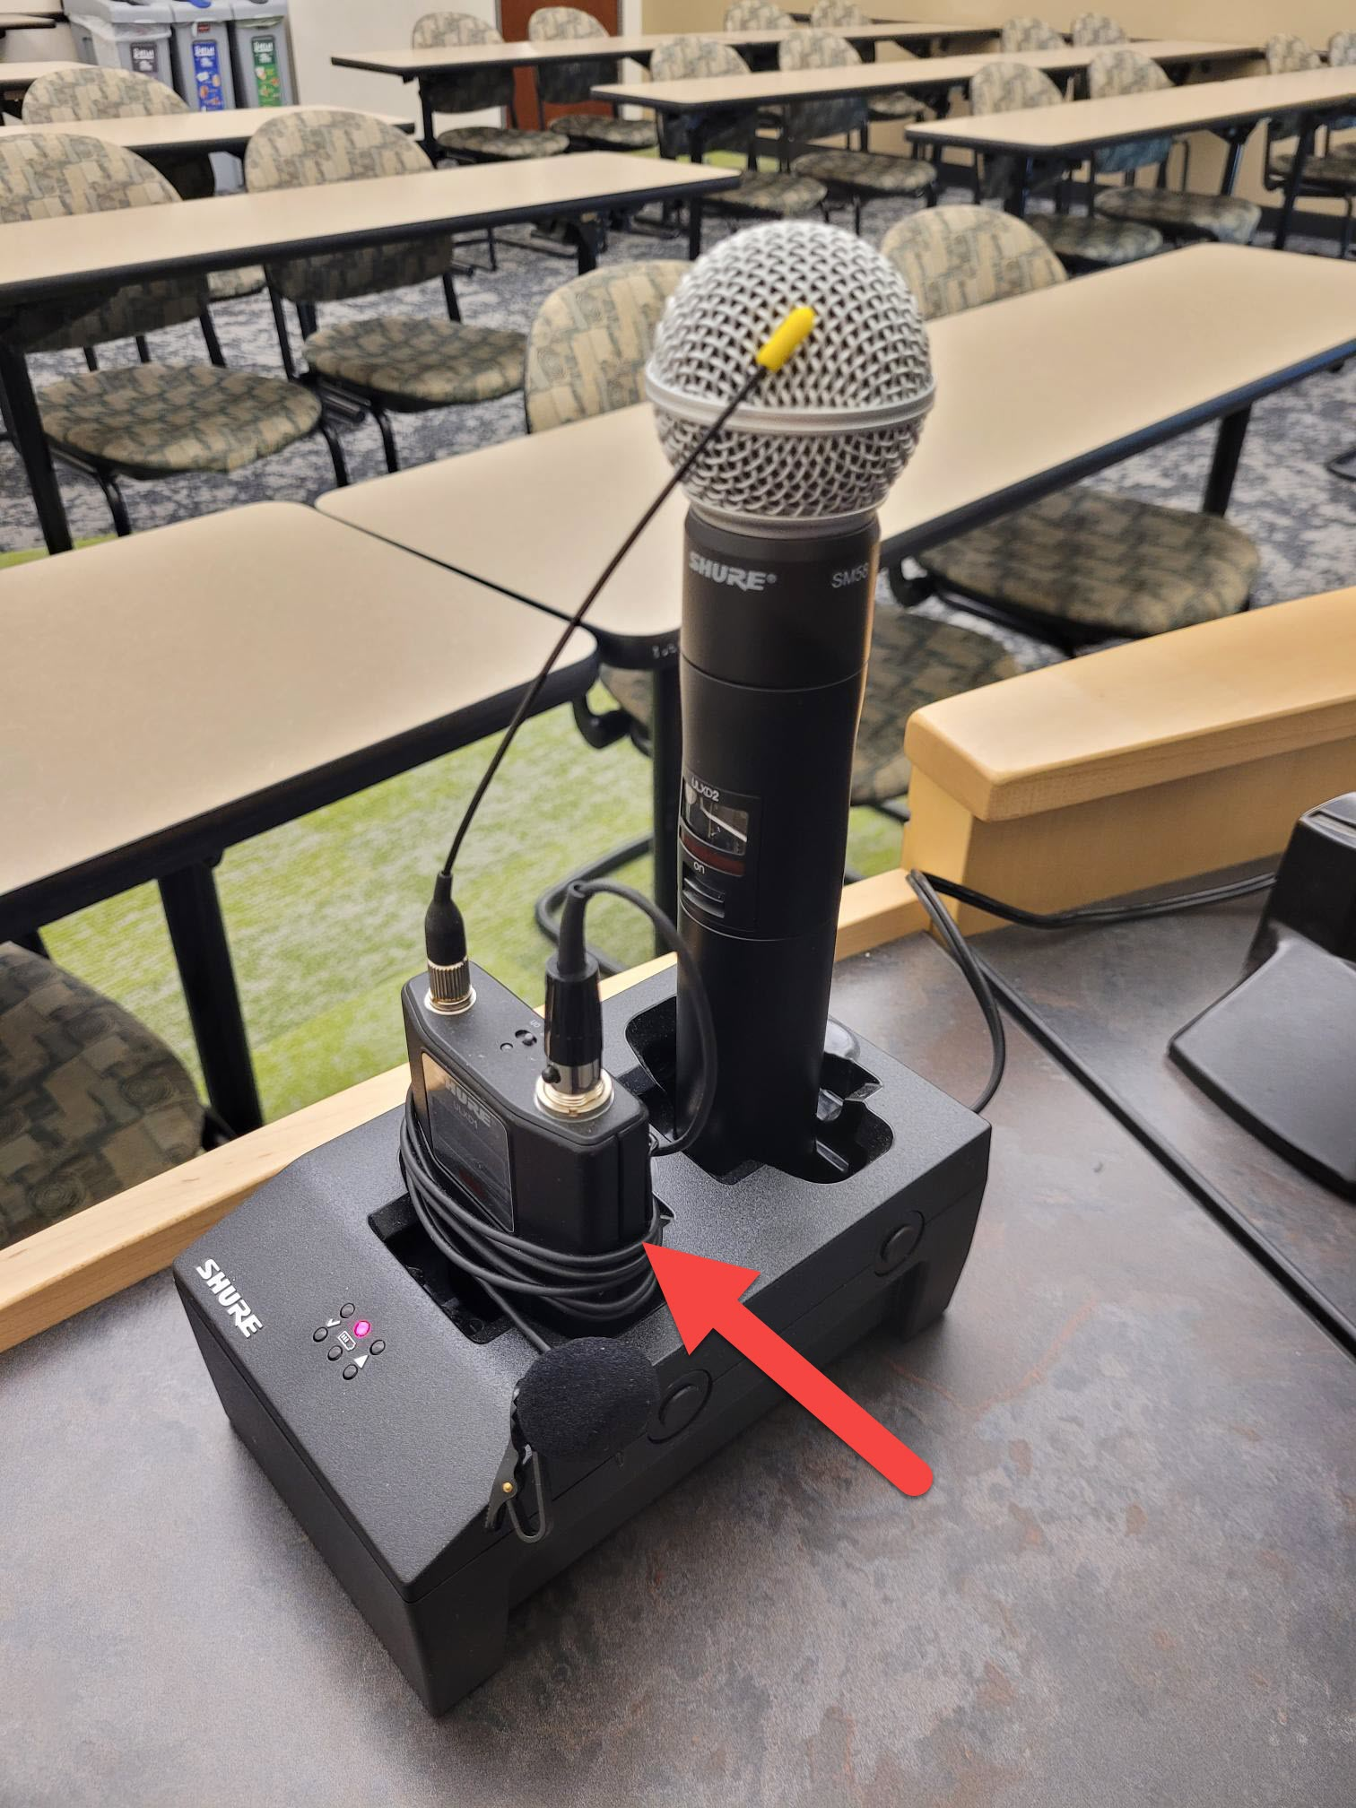

* Pull the Lapel microphone out of its dock.
* Locate the power switch on the top of the microphone and switch it to the on position.

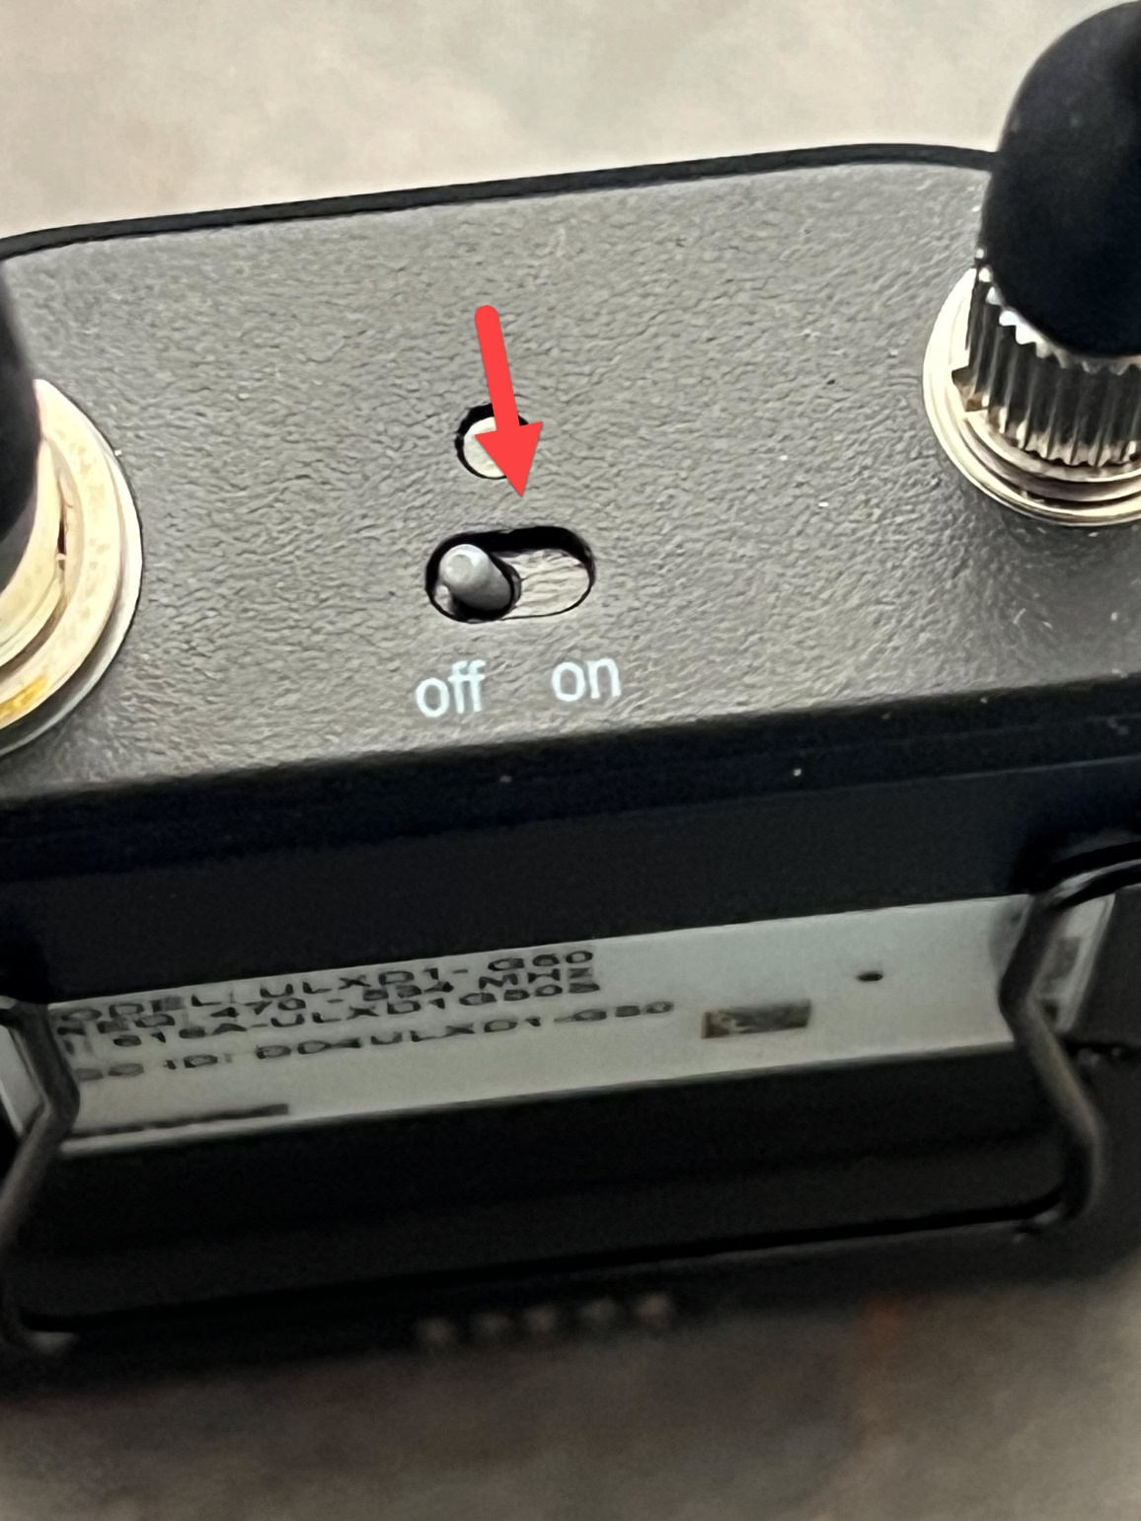

* You will speak into this piece of the microphone.
* This piece also has a clip so you can attach it to your shirt for easy access.

